Executive Summary
The project intends to identify the strategic factors affecting the hospitality industry. For the analysis, Hilton is selected for the study. Secondary data, news articles and literary works have been consulted to comprehend the environmental aspects that affect the business. It is observed that Hilton stands to be the market leader in hospitality sector. Hilton implemented numerous business strategies that gave the company competitive advantage over the rest.
Nonetheless, it is evident that the company lacked expertise in digital content writing and social media skills. It is recommended that Hilton impart digital training to their employees and recruit social media marketer to accelerate their growth further.

Table of Contents
Executive Summary 2
1.0 Introduction 4
2.0 Company Overview 4
3.0 Internal Strategic Analysis Tools 4
3.1 Hilton: McKinsey 7s analysis 5
4.0 External Strategic Analysis Tools 7
4.1 External Environment- PESTEL 7
4.2 Industrial Environment- Porters Five Forces 10
5.0 SWOT analysis 12
6.0 Organisation core competencies 13
7.0 Dynamic capabilities 14
8.0 Organisation sustainable competitive advantage 15
8.1 Present Strategy for creation of competitive advantage 15
8.2 The rightness of the strategy 16
8.3 Success of the strategy and future aspects 16
8.4 Alteration of Strategies for maximizing competitive advantage 17
9.0 Strategic Capability 18
9.1 Analysing the best approach towards strategic execution 18
10.0 Conclusion 18
11.0 Recommendation 19
Reference list 21
Appendices 24

1.0 Introduction
In this cutthroat competition, organisations are formulating edge-cutting schemes to float in the market. Business strategy outlines advanced policies and schemes that accelerates the growth of the organisation. The company considered for analysing the business strategy in this report is Hilton Hotels Corporation (Blanchard, 2018).
Hospitality sector is people oriented and the entire success of the trade depends solely on the relationship between the clients and the employees. Employees at Hilton Group Corporations are trained to foster the culture of serving people (Ondieki, & Kung’u, 2013). The main aim of this report is to excavate the aspects of hospitality business that made Hilton group one of the leading hotels in this industry.

2.0 Company Overview
Hilton Hotels Corporation is one of the leading hospitality conglomerate spread throughout the world. It is headquartered in America. Conrad Hilton established the organisation, back in 1919. Since that time, the company advanced gradually and in contemporary situation, it is spread in more than 109 nations. Initially, Conrad Hilton focussed on establishing the superior most hotel in Texas. His commitment, focus and approach to bring something innovative to the clients paved his journey of success. President and CEO of Hilton group claims that the workers serve the guests with passion and love, even beyond the physical facilities of the organisation (Corporatereport.com, 2019a).

3.0 Internal Strategic Analysis Tools
This section will evaluate the dynamics of hospitality sector and dynamics that made Hilton Hotels stand out in the competition and become the market leaders.

3.1 Hilton: McKinsey 7s analysis
McKinsey model of 7s is the device that evaluates the internal aspects of the business structure with the help of seven critical internal business dynamics. These dynamics comprises of structure, strategy, shared value, style, skills, staffs and system within the organisation. These elements are evaluated to assess whether the aspects aligned in accordance with company’s growth and expansion strategies (Alshaher, 2013).
Figure 1: McKinsey Model of internal factors
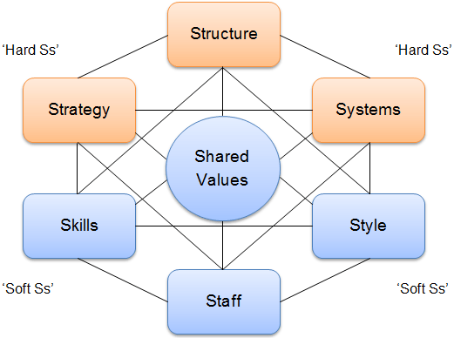
(Source: Singh, 2013)
This framework is applicable to analyse the business design of Hilton Hotels Corporation. This model facilitates in implementing new schemes, identifying the challenges faced by the organisation and renovating the organisational design. The seven factors of McKinsey in respect to Hilton Hotels is elucidated below:
Figure 2: McKinsey Model used by Hilton
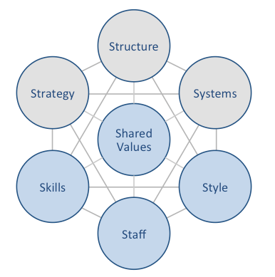
(Source: Corporatereport.com, 2019b)
- Shared Value: In the depiction above, it is evident that Hilton has placed shared values aspect in the core of its agenda. The primary agenda for this step is to value their employees and guide their behaviour that has implications on their performance. As the chief product of Hilton Hotels is to serve the customers, behaviour and attitude of the employees gains the prime spot (Corporatereport.com, 2019b).
- Strategy: Hilton’s business strategy concentrates on differentiating their entire service. The organisation differentiates their service based on quality of their service and advanced level of information and communication integration. This group of hotels classifies the service based on client recognition, position, status and achievements. It provides customer centric service to the users.
- Systems: the company provides excellent facility to their clients. It offers facility for quality control, consumer reservation system, and employee performance and worker retention system.
- Structure: Hilton Hotels Corporation is gigantic firm. For effective monitoring of the hotels, the organisation maintains hierarchal structure.
- Style: This represents the approach of managing employees and training the individuals for the customers. Organisation conducts workshops to develop their employees and impart appropriate skills (Naipinit, Kojchavivong, Kowittayakorn, & Sakolnakorn, 2014).
- Staff: Hilton Hotels do not depend on the HR manager only for monitoring their staff. Special manager are recruited to monitor the workers.
- Skills: The hotel identified their unique business skills and nurture those attitudes within their employees to represent unified image of the brand in Australia and worldwide (Corporatereport.com, 2019b).

4.0 External Strategic Analysis Tools

4.1 External Environment- PESTEL
PESTEL analysis is the framework that scans the external environment of the business that has profound impact on the performance of the company. This analytical device helps the organisation to enter new markets during expansion or to launch new products.
Figure 3: PESTEL factors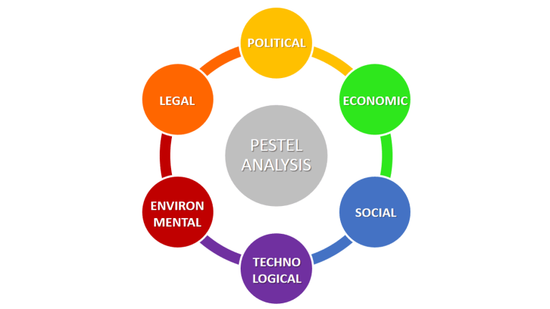
(Source: Yuksel, 2012)
The aspects of the macro-environment evaluated by PESTEL are discussed in the section below in correspondence with the Hotel giant –Hilton Hotels Corporation:
- Political Aspects: Political environment of the country highly influence the operational dynamics of the industry. The degree of support for new industry, relaxation for foreign investment and other government regulations in Australia play dominating role. Political stability of the current government in Australia, corruption level, tax policies and labour laws of Australia are matter of concern for Hilton. Moreover, CSR activities, education level, health regulations are evaluated. Political instability and terrorism activities adversely affect the hospitality sector (Yuksel, 2012).
Australia’s political condition is relatively stable, transparent and economically sound. Australian governance bagged the position in the global top five position in Index of Economic Freedom. The nation offers safe and progressive environment to Hilton Hotels for developing their business (Rumbens & Guttmann, 2019).
- Economic Aspects: National and international economic status affect the growth of the organisation. Economic growth in Australia will escalate the expansion of Hilton Hotels. For instance during any world class tournaments, Hilton Hotels are over booked and the organisation makes lots of profit. In addition to this, disposable income highly influences the hospitality industry. More the net income of the Australian citizens, greater will be there disposable income and higher standard of living. More number of individuals can afford the luxuries of the resort. However, in recent times Australia evidenced fall in their real estate business adversely affected their income level, which made the citizens cautious while spending money (Rumbens & Guttmann, 2019).
- Social dynamics: Broad range of social norms affect the business of Hilton hotels in Australia. Hilton is well-renowned brand in hospitality sector and visitors all around the planet visit Australia for relaxation and business. Evolving patterns of consumer lifestyle, demographic profile and local norms have profound impact on the business of Hilton in the country.
- Technological factors: Australia is technologically developed nation and promotes technical expertise. The Hilton group of industries incorporates advanced forms of technologies in their system. This organisation has introduced online booking system, feedback mechanism and facility management in their branches.
- Environmental issues: State, Federal and local government bodies in Australia jointly implements and monitors ecological protection acts. The administration in Australia is very stringent about their environmental policies. Hilton Hotels Corporation has to comply by the environmental norms for smooth functioning of their units in the nation (Business.gov.au, 2019).
- Legal obligation: Australian government have implemented large number of business registrations and restrictions. Goods and service tax, Tax file Number, Australian Business Number are few of the restrictions implemented by the government. Australian government has also incorporated restrictions over visa. This limitation has adversely affected Hilton service as tourists come from all over the world (Business.gov.au, 2019).

4.2 Industrial Environment- Porters Five Forces
Porter’s five forces analogy is the tool that analytically evaluates the business environment within the same industry. This very technique helps in analysing the forces within the industry that influences the profitability ratio of the organisation (Bharwani, & Mathews, 2012).
Figure 3: Porter’s Dynamics

(Source: Author’s creation)
- Threat from the existing rivals: Hilton hotels belong to premium class of resorts. The competition level in this class of hospitality industry is fierce. Shangri-La, Hyatt Regency, Four seasons, Park Hyatt are just few of the names in Australia that are giving tough times to Hilton. The organisation divested their income to different sections of the business, which is leveraging their business.
- Competition with the new entrants: the barriers to entry in hospitality industry is low, which is not supporting the business for Hilton. Large number of hotels and resorts are coming up in tourist locations of Australia and worldwide, giving intense competition to this brand.
- Negotiating power of vendors: Hilton has introduced a unique program named, Supplier Diversity Program, which allows the organisation to purchase from diverse range of vendors, giving them uniqueness and cost leadership. Bargaining power of vendors are low in case of Hilton, as the company buys their supplies from large number of vendors. The firm provides a platform for competition among the vendors to serve such a large estate.
- Threat from substitute services: In hospitality sector, especially in Australia substitute services are irrelevant. The clients are generally tourist or business class people. The customers do not have an option of substitute other than relatives’ place, the ratio that tends to be so negligible that Hilton do not face any challenge in this sector.
- Bargaining power of buyers: Hilton encounters huge pressure due to negotiations from customer end. The clients has huge range of hotels to select from the luxurious range of resorts. Therefore, the clients enjoy high bargaining power in this aspect (Hilton.com, 2019).

5.0 SWOT analysis
SWOT analysis is the strategic evaluation of the core elements of the organisation itself. It gives an opportunity to utilise their core competencies and improve in the domains where the company lacks behind. This tool aid in self-evaluation. This evaluation is based on evidences, facts and real data available to the executives of the firm (Robinson, Fallon, Cameron, & Crotts, 2016).
Table 1: SWOT analysis: Hilton
Strength  - Strong dealer network  - Outstanding reputation in market  - Superb track record  - Large investor network  - Heavy returns on expenditures  - Excellent customer feedback  - Skilled and trained employees | Weakness  - The firm encounters problem while integrating their work culture at different nations. The company is originally established in America. Working culture in Australia is quite diverse.  - The liquid asset ratio of the company suggests that the financial planning of Hilton is not effective.  - Hilton do not invest appropriately in the fields of research and development.  - Hilton is facing huge attrition rate. Employees are leaving their jobs at Hilton frequently, which adversely affecting their productivity and quality of service.
Opportunity  - As the customers are inclining towards modern facilities and luxurious life style, it will open new arenas for Hilton.  - Investments over developing online platform for customers have opened new sales line for the organisation.  - Due to low inflation rate in the country, will give more stability to the market. This will help the organisation giving credit to the clients at lower charge. | Threat  - Increasing cost of raw material is posing threat to the smooth functioning of Hilton.  - Hilton is operating in more than 109 countries all throughout the world. It is prone to currency fluctuations.  - New regulations implemented by the government bodies are continuous form of threat.
(Source: Author’s Creation)

6.0 Organisation core competencies
Core competencies of the organisation outlines the niche that the company has created for themselves in the market through their valuable services and unique products. Hilton hotels have achieved their goals and crafted their niche in the minds of their customers through their sheer dedication and extraordinary service to the individuals. Customer satisfaction is the core to their service strategy. The founder has visioned to provide excellent service quality at their hotels. This is the backbone of their success journey. This is evident from the fact that the organisation received the prestigious J.D. Power award for maximum guest satisfaction level. Integrity of the customers are maintained strongly within the hotel. The resort has streamlined their activities to achieve specific goals and increase client royalty. Hilton Hotels maintain balance between their skills and resources. Strong and transformational leaders have motivated their employees to serve the visitors with passion. These individuals have escalated the feeling of oneness among the teammates to maintain single image of the resort in front of the customers (Morris, & Metternicht, 2016).

7.0 Dynamic capabilities
Dynamic capabilities of Hilton will sketch their ability to identify, build and assimilate their internal and external competencies to compete with the dynamic business environment. Hilton is open for international commerce, and itself indulges in global expansion. To integrate their services and compete in the foreign land, the organisation rapidly undertakes technological advancements and deliver services that cater to client needs. Hilton has developed both the international and national market domain for their services (Nieves, Quintana, & Osorio, 2016). Hospitality sector is in constant flux and Hilton is continuously evolving their service components to balance this turmoil. Hilton uses the dynamic framework that employs non-imitable capabilities. This accounts for their intangible assets, which gives them economic leverage. In addition to this, performance of the organisation is critically monitored. It is compared with past performance to comprehend the current state of improvement that will influence the future scopes (Hoque, & Chia, 2012).

8.0 Organisation sustainable competitive advantage

8.1 Present Strategy for creation of competitive advantage
Hilton Hotels Corporation dominated the market owing to their service differentiation strategy. The decision itself became the milestone for the organisation. It gave them competitive leverage over the rival companies. Services provided by Hilton Hotels Corporation is classified based on quality, and standard. This classified form is integrated with advanced levels of information technology. Inculcating digital platforms in their various service options made the hotels stand out in the stiff competition (Koseoglu, Ross, & Okumus, 2016).
Figure 4: Competitive advantage of Hilton
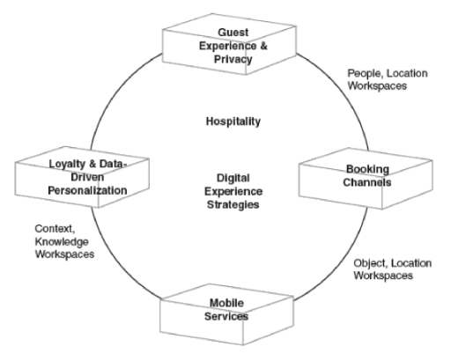
(Source: Hilton.com, 2019)
Organisation’s digitization schemes include mobile services, data driven personalization, reservation channels, loyalty programs, privacy and integrity of the visitors and feedback of the customers. Integrating these digital aspects along with the traditional form of service synergistically impacted the functioning of Hilton Hotels.
The organisation comprehensively expands their business beyond the national boundaries and integrates with the foreign culture to become one of the local serving the nation. The Hilton Hotels Corporation follows aggressive business expansion strategies and market entry plans based of their service differentiation (Hilton.com, 2019).

8.2 The rightness of the strategy
It is quite evident from the success of the organisation that the digitisation, integration and service differentiation are justified approaches. Digitisation in the hospitality sector has made reservation process easier for the consumers. Furthermore, the visitors can verify about the Hilton hotel prior to booking through customer feedback given by the previous users. Consumer feedback mechanism over online platform has indirectly increased the awareness about the brand. In addition to this, the individuals can verify different facilities provided by the hotel. Clients can compare the facilities and cost structure of Hilton with other renowned resorts of Australia prior to making decision. This helps in increasing clarity with the customers (Bucur, 2013).

8.3 Success of the strategy and future aspects
After getting immense success with the current strategies, Hilton has planned to open their first resort at West Australia. According to the proposed designs, the premium hotel will be located at Kalgoorlie Golf Course. Hilton will operate double Tree hotel, and the developmental project is assigned to Pacifica Developments. The design is finalized and the construction estimate for the golf course itself is approximately 4 million dollars. This adventure is not just premium but exotic vacation location. This plan is the seventh hotel opened by Hilton in Australia. Currently, it has 27 properties only in Australia. Plans of expansion does not end with this venture, instead their strategic moves have devised to launch their magnificent resorts in New Zealand as well. By the end of 2023, the company has dreamt to open a chain of Hiltons across New Zealand. The primary cause of such tremendous growth is their service differentiation strategy that appeals to the clients and appeases them (Net, 2019).

8.4 Alteration of Strategies for maximizing competitive advantage
Though Hilton is succeeding owing to their unique service differentiation stratagem, nonetheless, the chances of counterfeiting their schemes is very likely by the competitors. The organisation needs to alter their strategies frequently to maintain their exclusive service for their customers and maintain their loyalty. Modifying the stratagem regularly, in accordance with the changing demand will also bring consumers more close to the organisation (Hilton.com, 2019).
Though the exotic hotel adapted digitisation, yet it is observed that the company failed in social media marketing due to poor content. Appropriate and attractive content for webpages are pre-requisite for branding. Moreover, Hilton is not able to use social sites to their full potential. Hilton professionals do not do personal interactions over social media sites, which is another reason of their failure, despite digitisation. Individuals go through the webpages and different social sites randomly. Attractive pictures, event information and images of picturesque locations lure the persons using the service. However, Hilton did not give much importance to this form of marketing (Hilton.com, 2019).

9.0 Strategic Capability

9.1 Analysing the best approach towards strategic execution
Strategic capabilities of Hilton outlines those events, which harness all available resources and skills in order to achieve competitive advantage over their competitors and float in the industry. In order to achieve competitive advantage, Hilton made three strategic moves. The company aligned their mode of entry along the cultural lines. It cannot appeal to the citizens of the nations without associating with the individuals there. Therefore, first strategic move was to match their resources and skills along the national culture. Next Hilton targeted to expand their business to the emerging markets (Molina-Azorin et al., 2015).
The company identified the business opportunities in the foreign land and expanded accordingly. The company possess adequate experience to deal with the fluctuations in demand and technological changes. Hilton positioned their hotels both for luxurious relaxation and for business class. Hilton is not only the market leader; it is innovation leader of the industry. The organisation achieved this position due to effective execution of their service differentiation strategy, HR policies and CSR activities. It did not leave any stones unturned to attain the first position in the market (Hilton.com, 2019).

10.0 Conclusion
From the above factual data and secondary analysis it can be concluded that Hilton is able to thrive in this cut throat competition for 100 years due to their remarkably striking strategies, customer focused services, and technology advanced systems. Hilton gave most importance to shared values of McKinsey’s framework, which proves that customer care is utmost important for this firm. PESTEL analysis highlighted that the political and economic conditions in Australia are stable for Hilton to expand. However, Hilton should comply with environmental norms, and legal obligations.
Threats from new entrants and existing rivals and bargaining power of buyers are high for Hilton. Nonetheless, bargaining power of the suppliers and threat from substitute services are low. Hilton has strong network of dealers, superb record of accomplishment, and excellent service quality as their strengths. Nevertheless, it fails in integrating with different cultures of Australia. Organization’s record of customer satisfaction is their core competent domain. Service differentiation and digitization strategy have made Hilton the market leader. These two aspects alienate the organisation from the rest. Nonetheless, it can be established that the hotel chain is growing owing to their effective skills of satisfying the clients.

11.0 Recommendation
From the above analysis, it is observed that though the company adapted digitation schemes, yet it is unable to create awareness through digital media. It is recommended that Hilton focus their next move in improving digital skills. It should impart digital training to their employees.
Moreover, the company is not using the potential of social media sites to their fullest. Professionals must be recruited, who expertise in social media marketing. Panel of members should be instructed to answer to the queries over social media sites by the prospective clients (Hilton.com, 2019).
To impart training and skills to the workers about digital tools will help the company to empower the individuals to face the competition in contemporary times. The net sales will increase if proper content is written through digital tools.
Social media marketing is the newest form of promotional tool that reaches to trillions of people in the entire world. It can spread the information within seconds. Thus, recruiting social media expert will aid in branding the company in every corner of the planet.

